# 4. How to do a NOT query in Django queryset?

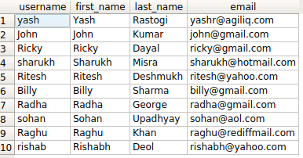

If you are using django.contrib.auth, you will have a table called auth_user. It will have fields as username, first_name, last_name and more.

Say you want to fetch all users with id NOT < 5. You need a NOT operation.

Django provides two options.

* exclude(<condition>)
* filter(~Q(<condition>))

# 4.1. The query in detail

Our SQL query for the above condition will look something like

SELECT id, username, first_name, last_name, email FROM auth_user WHERE NOT id < 5;

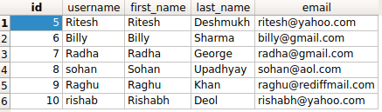

Method 1 using exclude

>>> **from** django.db.models **import** Q

>>> queryset = User.objects.exclude(id__lt=5)

>>> queryst

Method 2 using Q() methods

>>> **from** django.db.models **import** Q

>>> queryset = User.objects.filter(~Q(id__lt=5))

>>> queryst

<QuerySet [<User: Ritesh>, <User: Billy>, <User: Radha>, <User: sohan>, <User: Raghu>, <User: rishab>]>